State Wetland Authority Kerala (SWAK)
4th Floor, KSRTC Bus Terminal Complex, Thampanoor,Thiruvananthapuram-695001
Ph: +91471-2326264(Off);(Dir, Envt &Climate Change)
E-mail: swak.kerala@gmail.com swak.envt@kerala.gov.in

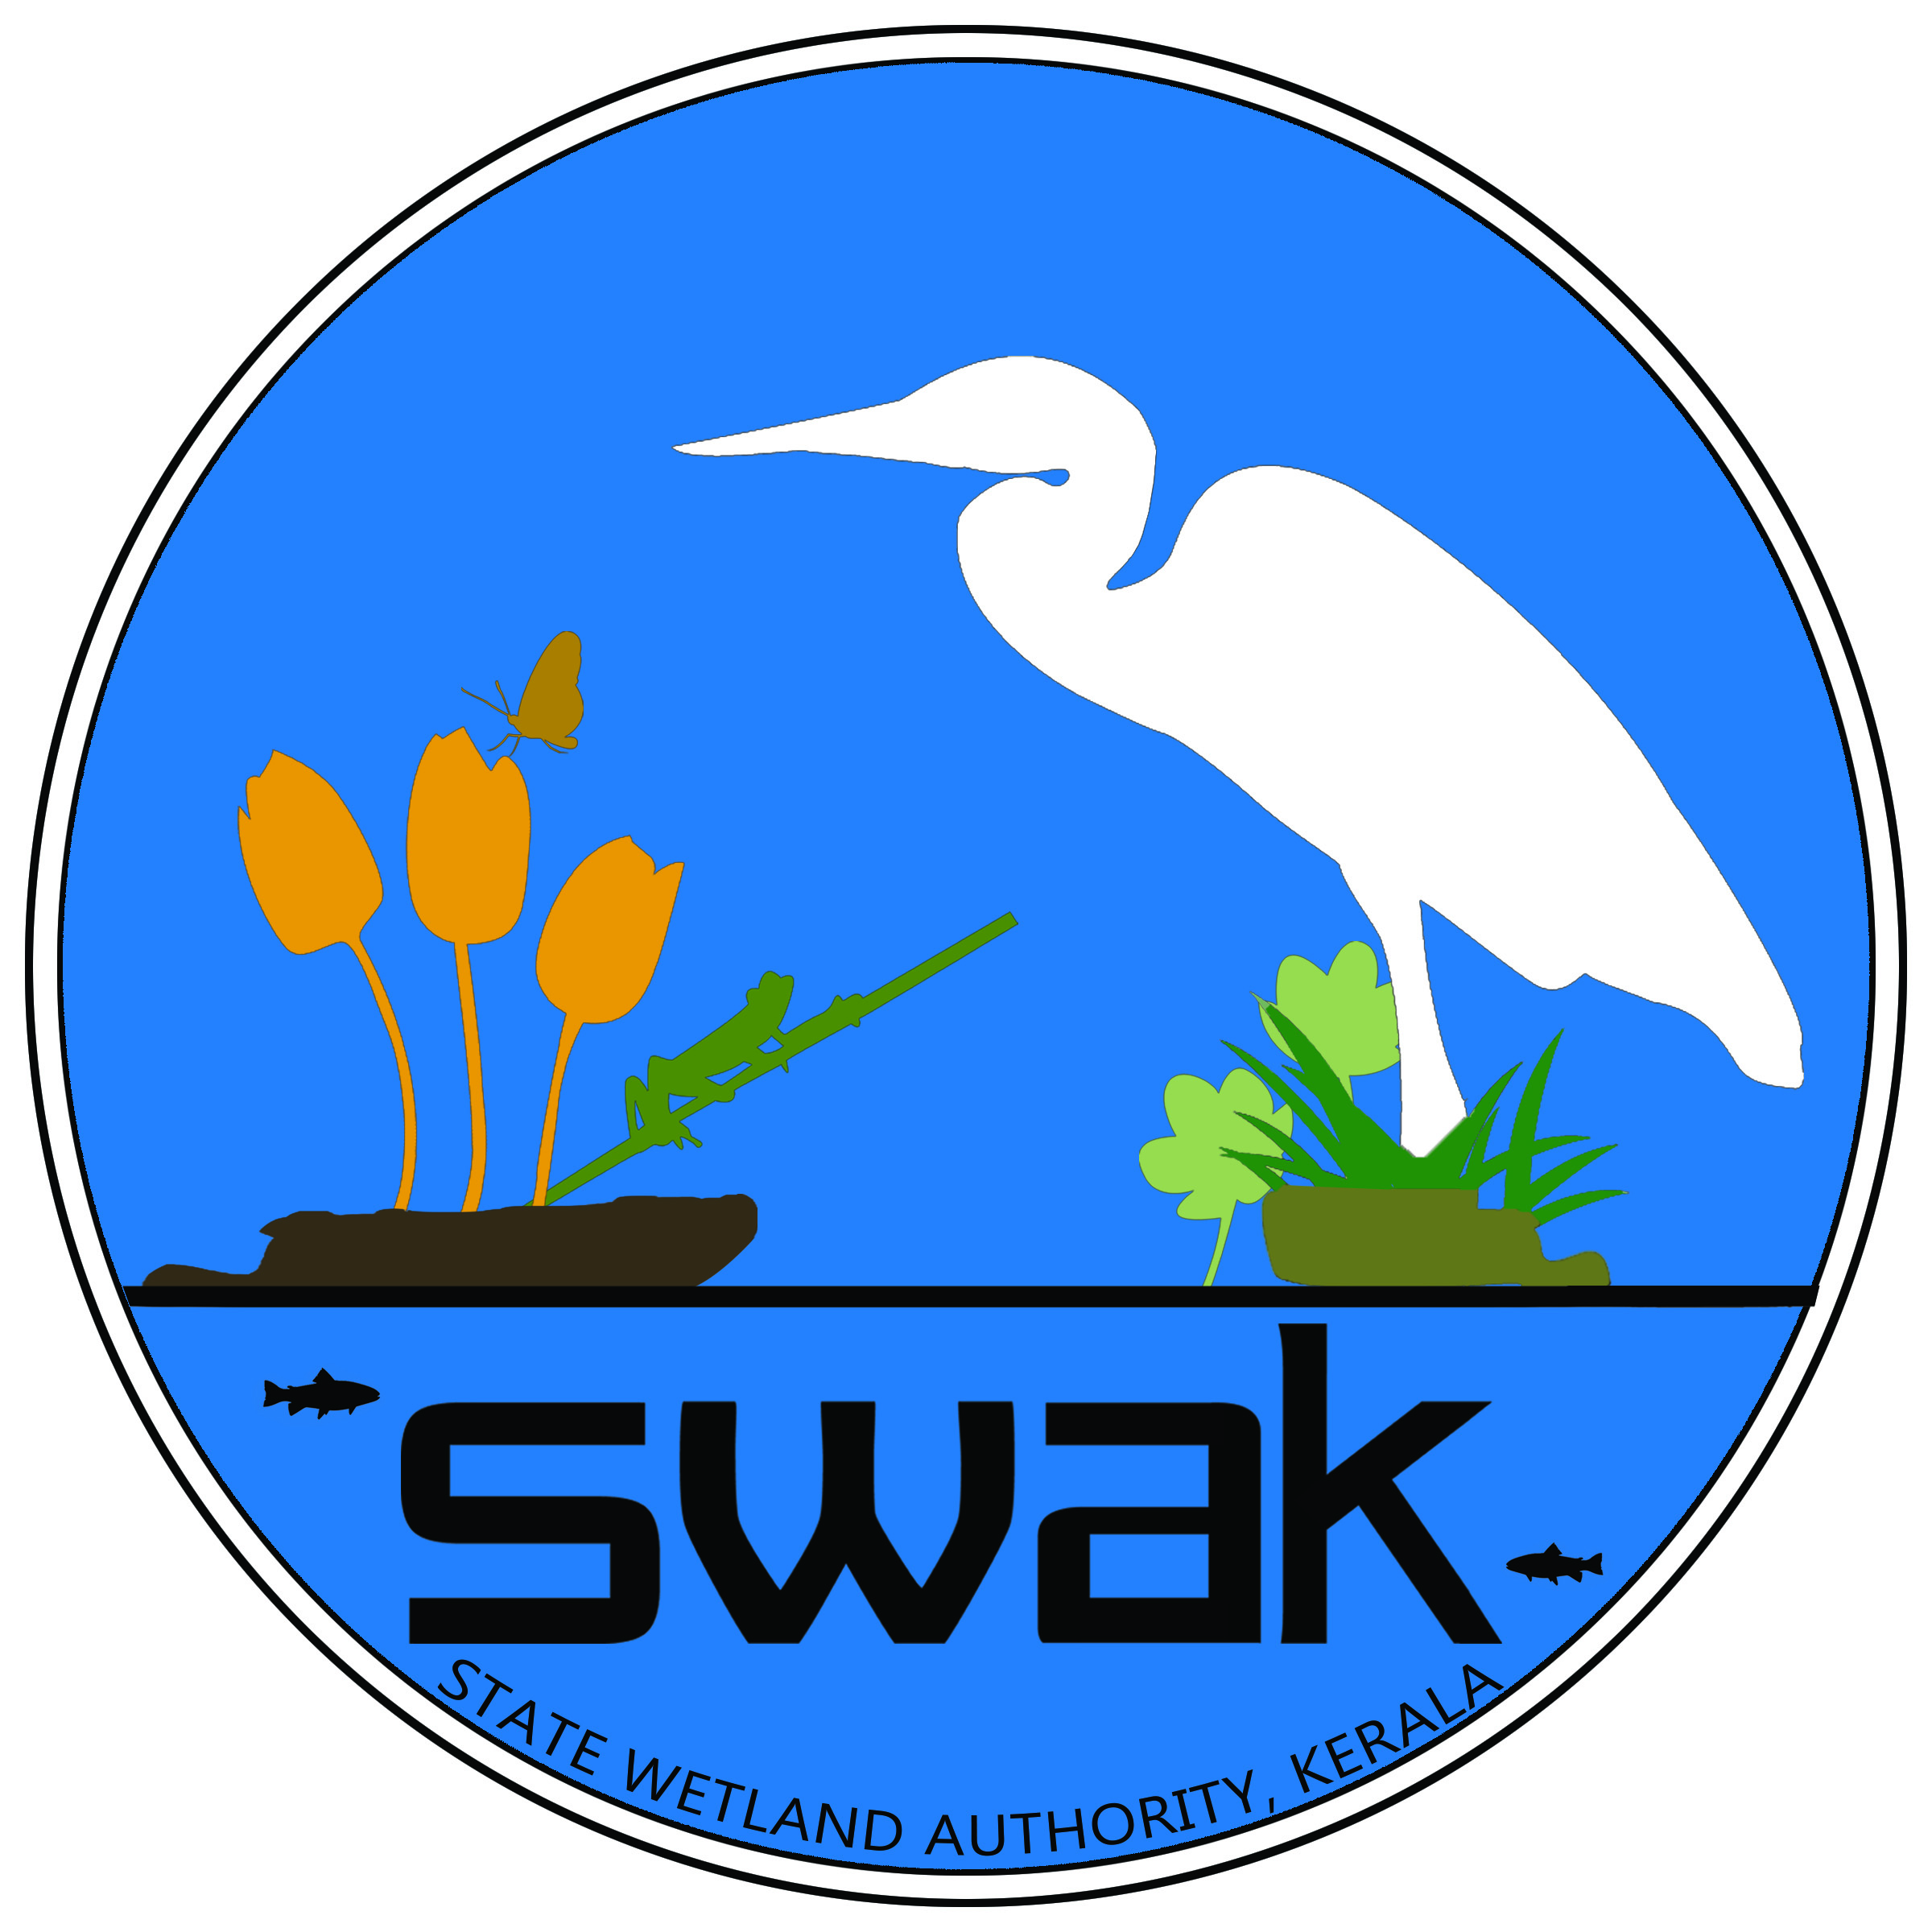
Recruitment of contract staff for the Implementation of Integrated Management Action Plan for the 3 Ramsar wetlands of Kerala –Vembanad-kol, Ashtamudi & Sasthamkotta and other technical activities of the Authority

Application form

# Application for the post of ……………………………………………………………………………..

Full Name (in Capital Letters) |  |  |  | :
Date of Birth, Age |  |  |  | :
Mobile Number |  |  |  | :
Email id |  |  |  | :
Sex |  |  |  | :
Address for Communication |  |  |  | :
Educational Qualifications (Attach self –attested copies of the proofs)
Sl.  No | Degree |  |  |  |  | University | Year of Passing | % of marks
Experience
(Attach self –attested copies of the proofs)
Declaration
I solemnly declare that all the above information is correct to the best of my knowledge and belief.
Date

Signature
Name

# Separate application to be given for each post.

