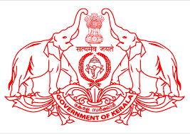

Government of Kerala
KERALA CENTRE FOR INTEGRATED COASTAL MANAGEMENT
(SPMU-ICZM/ENCORE PROJECT)
K.S.R.T.C Bus Terminal (4th Floor) Thiruvananthapuram- 695 001
Ph:+ 0471 2326264 (Off), 2322554 (Fax)
e-mail: kcicm2020@gmail.com; web: www.envt.kerala.gov.in

Notification No: 1/2020 26.06.2020
NOTICE FOR SUBMISSION OF APPLICATION
The Kerala Centre for Integrated Coastal Management (KCICM) invited applications for various positions vide Notification No: 1/2020 dated 16.03.2020. The last date for submission of application mentioned in the notification was 15.04.2020. Due to novel Corona, the last date was extended vide even notification no dated 16.04.2020 and the same was published in the website. It is to inform that the last date for submission of application is 05th July 2020. Those who applied earlier to this notification need not to apply.

Sd/-
Additional Project Director
KCICM

